Annandale Swim and Tennis Bios

Mitchell Frank
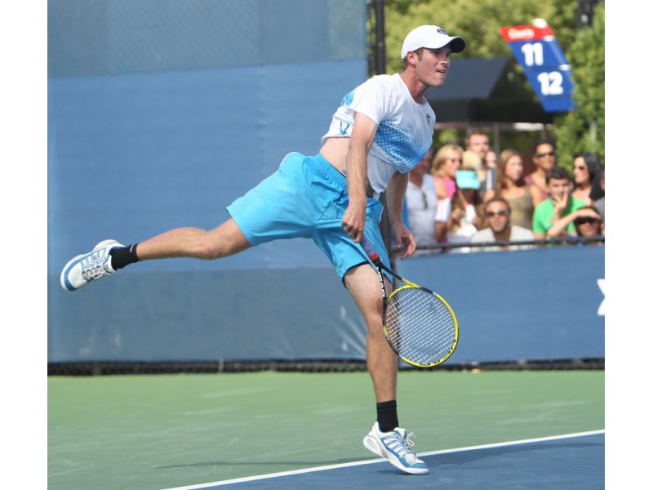
Mitchell Frank is the founder of Mitchell Frank Tennis LLC. One of the most highly decorated American players, he was a former top 5 junior in the world, 6-time NCAA Champion while at UVA and has served as a hitting partner for 20-time Grand Slam Champion Roger Federer. He brings his vast knowledge and passion for the game to kids and adults of all ages to help all players improve and learn invaluable life skills through tennis!

Nick Barker
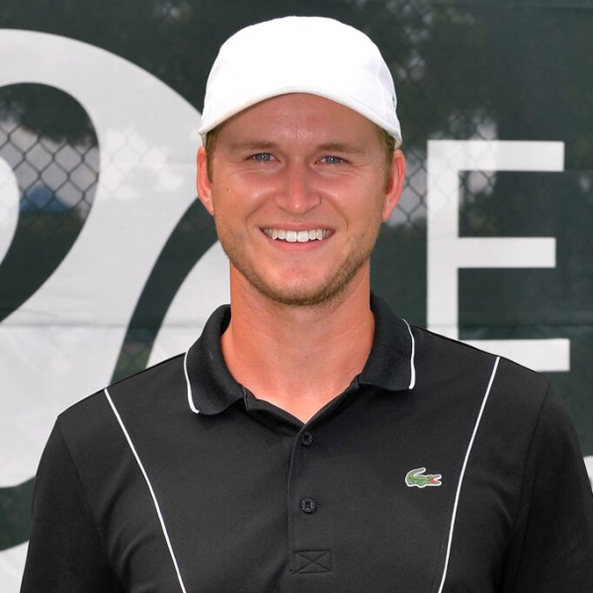
Nick Barker is a former Division 1 Tennis Player at George Mason University where he found success in both singles and doubles. He has since worked with world-class juniors while at the infamous Evert Tennis Academy in Boca Raton, Florida. He has worked with players who have been ranked top 100 in the world in juniors and has served as the hitting partner for John McEnroe. Nick brings a ton of knowledge and experience in what he has learned as a player and a coach.

Dylan Moran
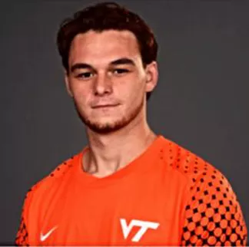
- Dylan Moran has played both soccer and tennis since he was a young kid. Dylan ended up choosing soccer and went on to play Division 1 soccer at Virginia Tech. He began coaching and developed a goalkeeper coaching program at age 14, which led to coaching at various clubs in the Northern Virginia area for the years to come. However, he has watched and learned as both of his brothers went on to have spectacular tennis careers in high school, college and later playing overseas professional tournaments. Dylan enjoys training athletes in both soccer and tennis at any level and takes immense pride in his students’ success.oped a goalkeeper coaching program at age 14, which led to coaching at various thletes in both soccer and tennis at any level and takes
- Jack Kearney is a rising Sophomore at Falls Church High School where he is active with the cross country, swim and tennis teams. This is Jack Kearney’s fourth year as a member of the AS&T swim team, and second year as an assistant tennis coach. Jack started playing tennis at the age of 8. He has enjoyed playing both singles and doubles on various teams through ninth grade, as well as assisting at team practices with the younger players. He is really looking forward to returning this year as an assistant coach with the tennis program at AS&T!
o brothers who played D1 collegiate and overseas tennis his tennis career began at a young age and continued past high school. He began coaching and developed a goalkeeper coaching program at age 14, which led to coaching at various clubs in the Northern Virginia area for the years to come including running the junior goalkeeper program at Mclean Youth Soccer Association. Dylan enjoys training athletes in both soccer and tennis at any level and takes immense pride in his students’ success.

